Submitting Exam Proctoring Instructions

Important Note:
- Course instructors must submit proctoring instructions each semester for students taking exams with SDAC.
- Instructors can provide these instructions by either:
  - Clicking the link in the email received once a student exam request has been submitted, or.
  - Logging into the SDAC Faculty Portal

**Please email sdac@virginia.edu with any questions or concerns. **

Submitting Exam Proctoring Instructions

Step 1
If you clicked the link provided to you via email, skip to step 3. Otherwise, log into the SDAC Faculty Portal using NetBadge. On the left-hand menu options, select [1] Alternative Testing.
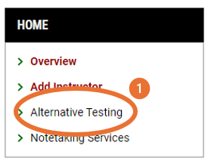

Step 2
Select [0] Proctoring Instructions from the top navigation bar. On the next screen, select [1] Courses without Proctoring Instructions and then scroll down to select [2] Specify for the specific course(s).
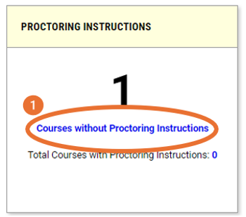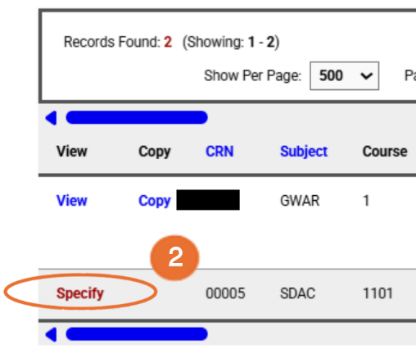

Step 3
Under Available Options for [Course], indicate whether SDAC will proctor your exams or not in the [1] Exam Management Method, [2] Confirm task by selecting Confirm to Proceed, and [3] submit the form by selecting Submit Your Selection.
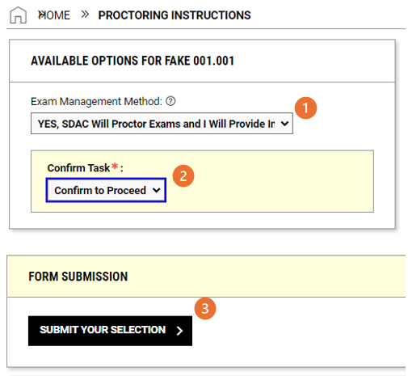
Continue to the next page and additional steps if you need SDAC to proctor your exams.

Step 4
Next, please fill out the mandatory proctoring instruction details [1] List of Questions
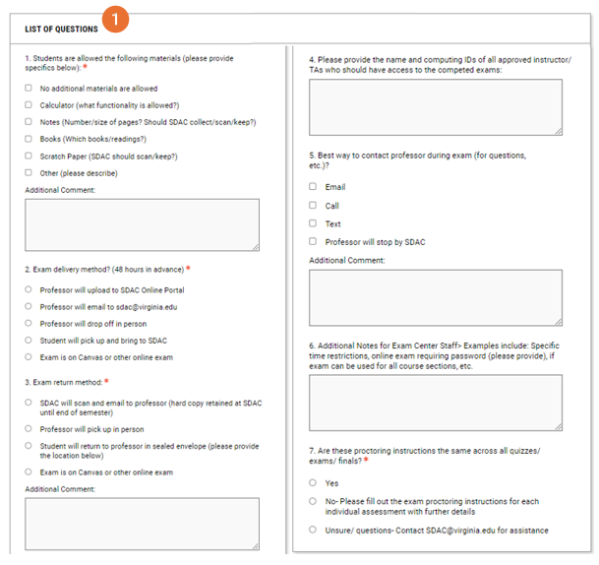
[2] Provide your contact phone number (cell/office) where a student or SDAC staff may reach you with an urgent question about the exam.
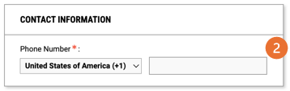

Once completed, please select Submit and Continue to Specify Exam Dates.
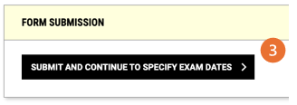
Step 5
Please provide exam details. [1] Type (Exam, Final, Quiz, Midterm), [2] Date, [3] Time, and [4] Standard Length of Exam.
**Note: For exam length please write the time in minutes for the regularly scheduled exam. Please do not include the extra time; we will calculate that for you. For example: 1 hour 15 minute = 75 minutes or 3 hours = 180 minutes**
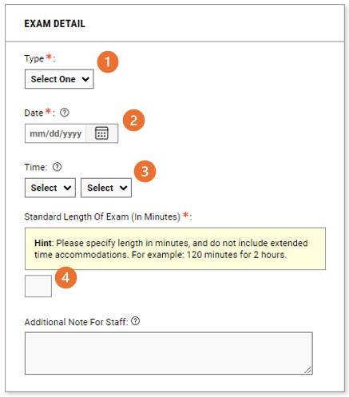

Provide any additional [1] exam specific instruction and [2] upload exam file (if already prepared) and select [3] Save Exam Date.
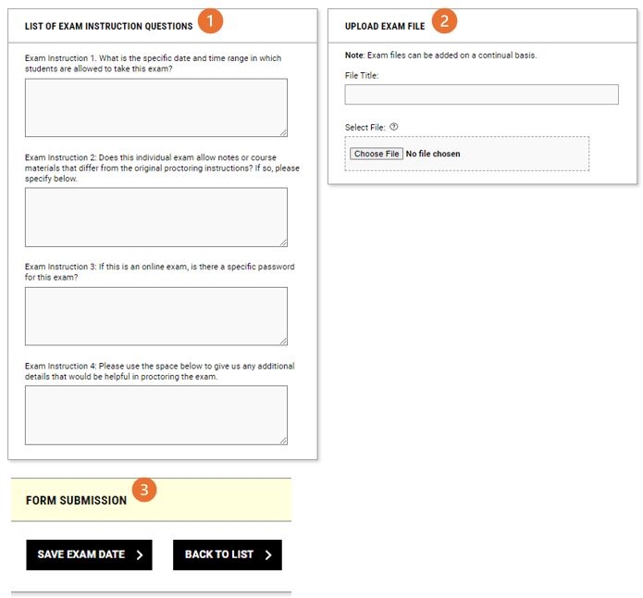

Step 6
At this point, you can see [1] List of Exam Dates, [2] modify or delete proctoring instructions already provided, or [3] Add Additional Exam Date(s).
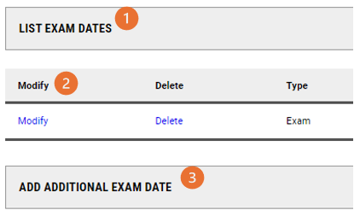

Modifying or Adding Additional Proctoring Instructions

Log into the SDAC Faculty Portal using NetBadge. On the left-hand menu options, select Alternative Testing and then on the top right menu bar select [0] Proctoring Instructions
and then select [1] View to view or modify Proctoring Instructions or [2] Copy to copy previously made proctoring instructions to other courses
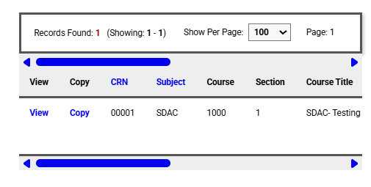
2
1

