Power Distribution Box: Assembly Instructions
NO$ν$A Project
Written By: Dale Mudd
September 21st, 2010

P#= Part Number
100A FEB Breaker
Pre-Box Construction

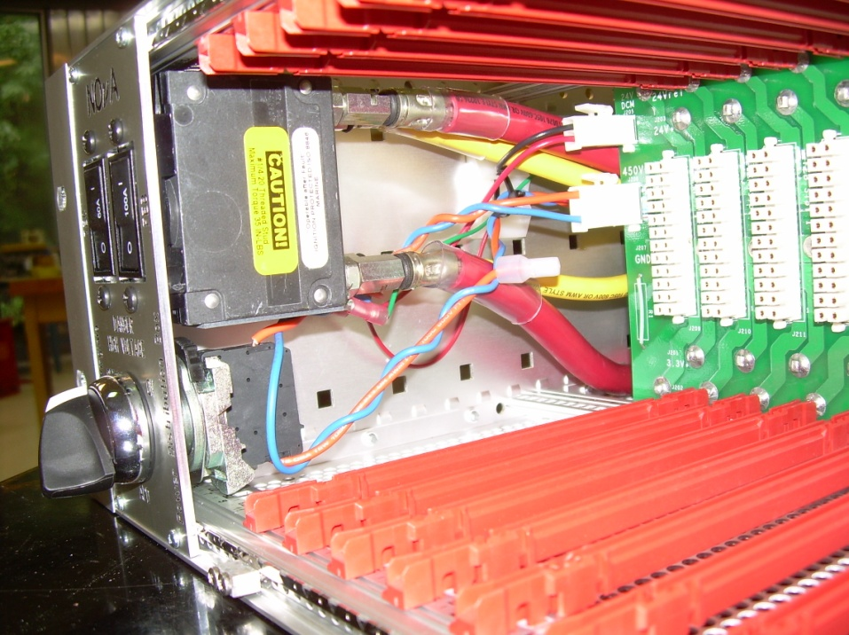
Figure 1
Toothed Washer
HV Switch Knob
Switch Panel Plate
60A TEC Breaker
Contact Block
Power Switch Panel:
1. Attach APD (high voltage) switch to switch panel plate. Start by twisting off the large toothed washer from the high voltage switch (P#: 9209K551, McMaster-Carr) and then sliding the knob it came off of through the circular portion of the switch panel plate such that the rectangular extension at the top of the switch slides into position with its equivalent cut in the panel. Next, fasten the toothed washer back onto the knob where it was before, only now it will be against the plate such that the teeth are digging into the plate. After that, install the contact block (P#: 9209K127, McMaster-Carr) behind the washer by simply pushing its circular aperture through the back of the knob protruding from the plate, ensuring that the arrow is facing upwards when attached. Lastly, place the black connector vertically such that it is aligned with the arrow and snap it into place behind the connector block. This means that the black connector should now be locked into position with the screw labeled “3” on the back above the screw labeled “4”.

2. Attaching the TEC and FEB breakers. Take either the 60A circuit breaker (P#: BS 7547, Blue Sea Systems) or the 100A circuit breaker (P#: BS 7549, Blue Sea Systems) from its box and open the enclosed bag of screws. Attach the switch to the front plane panel using the rounded (not flat) screws contained in the bag with an appropriately-sized Phillips screwdriver. The 60A breaker should be placed in the opening labeled “TEC”, while the 100A breaker belongs in the opening labeled “FEB”. They should be inserted such that the “on” position side is above the “off” position one. In other words, the longer side of the breaker should be closest to the top of the switch panel.

3. Repeat the process outlined in step 2 for the other of the two breakers.

4. Using a wrench, remove the outermost nut on each prong on the back of the circuit breakers as well as the washer set between it and the innermost nut on the prong.

Triax Washers
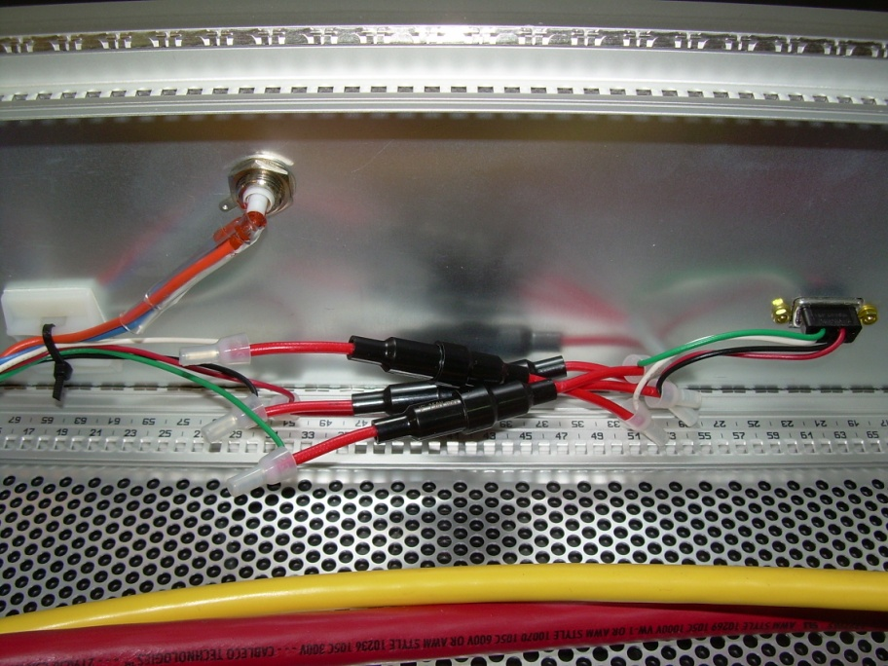
Sense Cables
Fuses and Fuse-Holder Wire
Cable Mount
HV Cables
Screw Lock Kit Parts
Triax Bulkhead
9 Pin Connector
Figure 2
Back Panel:
1. Slide a gold-plated triax connector bulkhead (P#: 5219, Pomona), with the high voltage cables attached in the manner explained in the “high voltage cables” section, through the semi-circular hole in the back panel, ensuring that sheltered side will be on the exterior of the box (determining which side of the panel will be the interior is simple to check- it will be the one in which the side flaps are pointing inwards).

2. Secure triax connector bulkhead with Q-slip washer followed by the nut that were also enclosed in the parts package.

3. Attaching 9 pin connector. Do this by inserting the black portion of the 9 pin connector (P#: 205203-3, Tyco), from the side of panel that will be the box’s exterior, though the appropriate aperture. This should have the black side on the box’s interior and the metallic side on the exterior.

4. Securing the connector. Using the screw lock kit (P#: 5205817-1, Tyco), fasten the 9 pin connector to the back panel from the exterior side such that, from the exterior to the interior, there is the screw head, two flat washers, the 9 pin connector, the back panel, a lock washer, and, finally, the nut included in the kit.

Box Construction
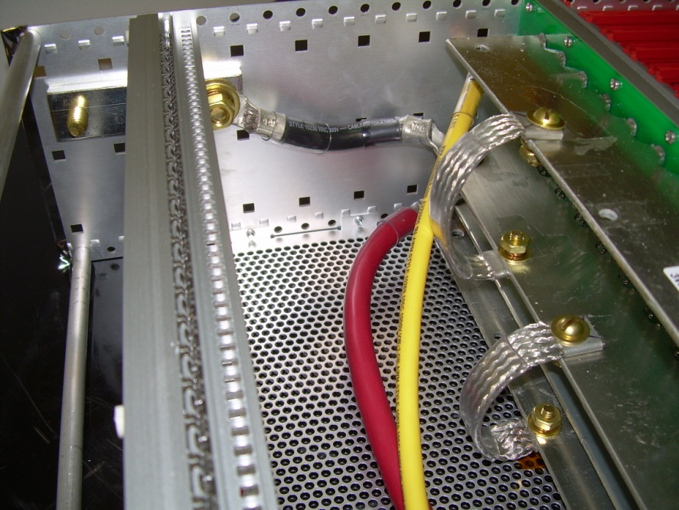
Flat Washer, Spring-Lock Washer, Nut
3/8” Size 16 Screw
Left Side Panel
Ground Connector
Figure 3
Ground Connector:
1. Take out the left side panel (P#: 34560-193, Schroff; Panel with two identical holes at rear instead of two sets of different sized holes). Note that the side that is to be the box’s interior is the one in which the two rows of indentations are popping out of the surface rather than going into it.

2. Place the ground connector on the interior side of the panel aligned with the holes in the rear for it and hold it in place using two 3/8”- 16 size screws of 1” length (P#: 92941A624, McMaster-Carr), with one flat washer (P#: 92676A450, McMaster-Carr) and one toothed washer (P#: 92164A031, McMaster-Carr) between each screw and the outside of the side panel. The toothed washer should be the one that is directly against the side panel.

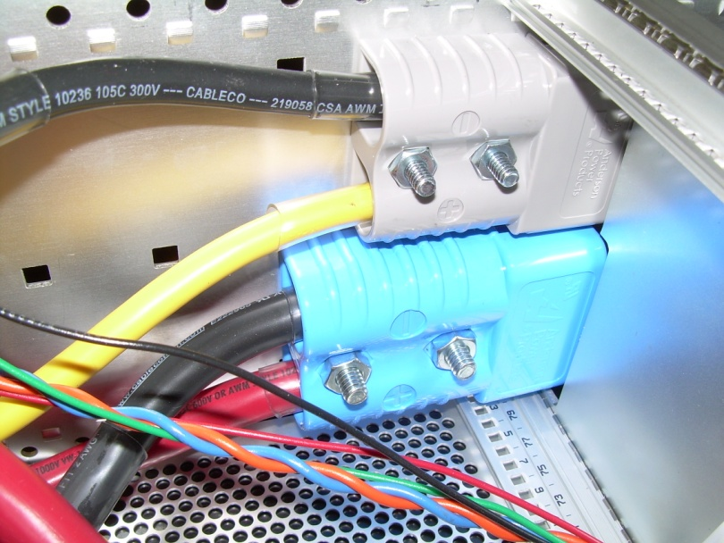
Size 20 ¼” Screws + Nut
10-24 Size 1 ¼” Screws + Nut
SB175 Marine Connector
SB120 Marine Connector
Indentions Pop Out
Right Side Panel
Figure 4
Marine Connectors:
1. Take out the right side panel (P#: 34560-193, Schroff; Panel with two sets of different sized holes in the rear). Note again that the side that is to be the box’s interior is the one in which the indentations are popping out of the surface rather than going into it.

2. Place the small grey marine connector (P#: 6800G3, APP) on the interior side of the panel from the first step and align it with the smaller set of holes that are closer to what will be the top of the side panel. Make sure that the larger openings of the marine connector are facing what will be the front of the box, i.e. facing down the longer stretch of the side panel.

3. Secure the marine connector using the 10-24 size 1 ¼’’ screws (P#: 90272A249, McMaster-Carr), one in each of the two holes, with a split-lock washer (P#: 91102A740, McMaster-Carr) and a flat washer (P#: 91090A103, McMaster-Carr) between each of the screws and the exterior of the side panel, with the flat washer being the one directly against the side panel. Lastly, secure the marine connector by placing a nut (P#: 90480A011, McMaster-Carr) on the exposed end of the screw protruding from the marine connector.

4. Repeat steps 2 and 3 using the larger blue marine connector (P#: 6326G5, APP), noting that a different set of screws (P#: 90272A546, McMaster-Carr), flat washers (P#: 91090A105, McMaster-Carr), split-lock washers (P#: 91104A029, McMaster-Carr), and nuts (P#: 90480A029, McMaster-Carr) are required.

Wings
EMC Contact for Cover
Type L-ST Connector Bar
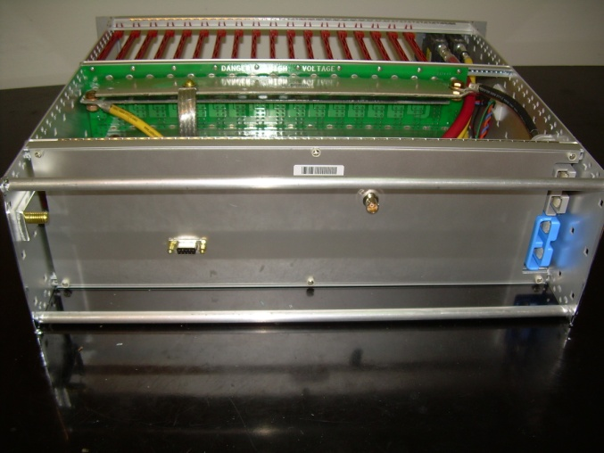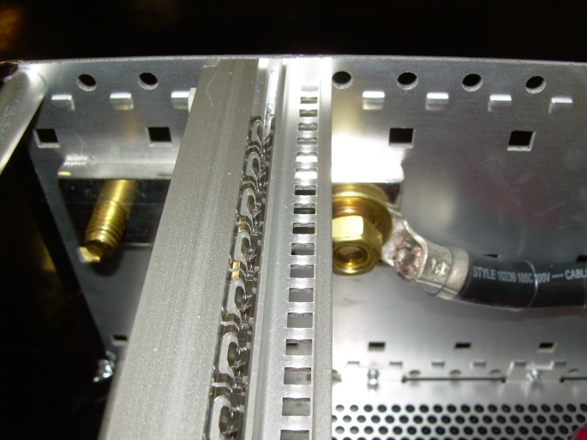
Kapton Tape
Stress Relief Bar
5th Hole from Rear
Type L-ST Connector Bar
Figure 5 Figure 6

Box Frame: (NOTE: “Bottom”= farthest from ground connector and grey marine connector)
1. Assemble the connector bars. For the four type L-SL connector bars (P#: 34560-184, Schroff), slide the threaded insert (P#: 34561-384, Schroff) in the bar’s innermost recess, the EMC contact for the cover plates (P#: 24560-246, Schroff) in the long rectangular groove on the top of the bar, and the EMC contact strip for the front and back panels (P#: 24560-236, Schroff) over the top of the shorter lip on the front of the bar. In addition to this, for two of these bars, hereafter referred to as the “front bars”, also slide the hole strip (P#: 30845-253, Schroff) in the recess in front of the one in which the threaded insert was placed. Secure the threaded strip (and hole strip for the front bars) with a single grub screw (P#: 21100-276, Schroff) through the hole at one of the far edges of the strips. For the two type L-ST connector bars, hereafter referred to as the “middle bars”, slide a threaded insert (P#: 34561-384) into the middle recess and secure with a grub screw (P#: 21100-276, Schroff) as before.

2. Connect the two side panels with one of the now-assembled front bars. To do this, insert the 14mm M4 screws (P#: 24560-130, Schroff) through the bottom hole of the wing parts (24564-197, Schroff), then first circular hole (i.e. the one farthest from the marine connectors and ground connector), and lastly into the front bar. Make sure that the front bar is positioned such that the numbers on it are facing upwards and its shelf of square slits is facing the interior of the box.

3. Connect the two side panels with one of the now-assembled middle bars. To do this, use the exact same screws as before (P#24560-130, Schroff) through the eleventh hole from the front, where the first hole is that in which the front bar is now connected, on the bottom of the side panels. Ensure that the middle bar is positioned such that its numbers are facing upwards and the shelf of square slits is the portion of the bar that is closest to the front bar.
4. Connect the two side panels with the rear bar (the type L-SL connector bar without the hole strip). To do this, continue to use the exact same screws as before (P#: 24560-130 Item 11, Schroff), but this time through the fifth hole from the rear of the box (23rd from the front). Ensure that the numbers are, again, face up and closest to the front bar.

5. Repeat the first three steps for the top set of holes in the side panels, with the only difference being that the numbers on them should now be pointed downwards towards the interior of the box. Use the same parts in the same locations.

6. Attaching the switch panel. Using four 10mm switch panel screws (P#: 92005A071, McMaster-Carr), attach the assembled switch panel to the front end bars positioned such that the side of the switch panel is flush against the right wing (close as possible to the side panel with the marine connectors).
2.5 Metric Screw

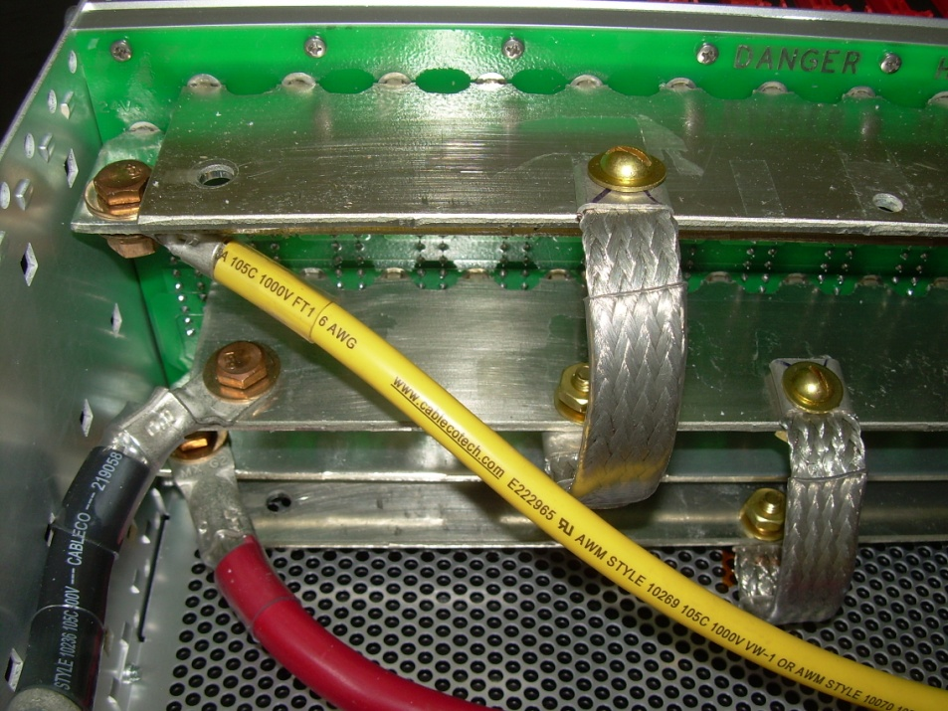
Bottom Source Busbar
Ground Cable
Bronze Screw + Flat Washer
9/16” Flat Washer + Split Lock + Brass Nut
TEC Cable
FEB Cable
Top Source Busbar
Bottom Return Busbar
Top Return Busbar
¾” 12-24 Brass Screws + Flat Washer
Ground Braid
Backplane
Figure 7
Backplane:
1. Attaching the ground braids. Place one end of a grounding braid over one of the holes on the center of the top return busbar. Screw in place using the appropriate screws and washers such that, from top to bottom, there is: a 3/4” #12-24 size brass screw (P#: 92453A294, McMaster-Carr), a 9/16” flat washer (P#: 92916A360, McMaster-Carr), the lug of the ground braid, the busbar, another 9/16” flat washer (P#: 92916A360, McMaster-Carr), a split-lock washer (P#: 93496JA418, McMaster-Carr), and a #12-24 brass nut (P#: 92671A013, McMaster-Carr). Attach the other end of the braid to the hole at the same location on the center of the middle return busbar using the same parts and procedure.

2. Repeat the above step for a braid connecting the other set of holes in the center of the center return busbar and the bottom return busbar.

3. Place backplane into box against the rear side of the middle bars such that the busbars are extending towards the back of the box, away from the card guides. The backplane should be flush with the box’s left wall such that there is an opening between it and the box’s right wall at the same location of the front switch panel.

3. Using a test FEB/DCM card in the both the leftmost and rightmost card guides, make sure that the backplane is positioned so that the cards are able to easily slide into and out of their proper connections with the backplane.

4. With this positioned determined, use 20 of the 2.5 metric screws (P#: 7985A4PH2.5X6, Brikksen) to fasten the backplane to the middle bars of the box, 10 for the holes along the top, 10 for the holes along the bottom.

5. Attach a Backplane barcode label on the center of the top return busbar such that it can be read by a person looking in from above when standing behind the box.

Attaching the Back Panel
1. Place the back panel, with the 9 pin connector and triax connector now on it, flush against the back of the rear bars such that the cut outs for the marine connectors and the ground bar are in the correct locations.

2. Secure in place using a combination of a retainer (P#: 21100-464, Schroff) and captive screw (P#: 21101-101, Schroff) through each of the six holes. The captive screws should screw through the retainers and catch in the openings in the rear bars.

Internal Cabling
Low Voltage Cables:
1. Peel off the backing of two mounting cradles (P#: MCNY-1250-9-C, Thomas & Betts) to reveal the adhesive. Place one of these cradles about 10cm towards the right side of the box (the side with the marine connectors) from the high voltage cable slot, and place the other as parallel as possible to the backplane on the side panel. When inserting the sense cables below, make sure all 4 are cable-tied to the first cradle, and that the red and green sense cables are cable-tied to the second cradle. Refer to Figure 2.
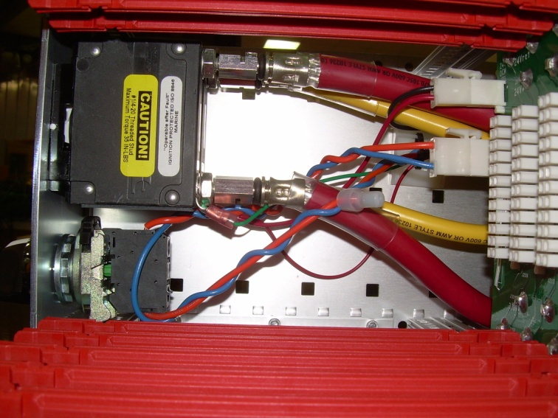
HV Connections to Breaker
Switch Panel
100 A Breaker
HV Cables + Busbar Connection
DCM Cables + Busbar Connection
Card Guides
Swivel Nut
Crimp-On Wire Connector
M6 Conductor Lug
Figure 8
2. Remove the nut and external tooth washer off of the bottom prongs of the 60A and 100A circuit breakers. Slide the M6 conductor lug connecting the red sense and red DCM cable on the prong protruding from the bottom of the 60A breaker and the M6 conductor lug at the end of the green sense cable on the prong protruding from the bottom of the 100A breaker. Slide the external tooth washer and nut back over the prongs.

3. Attach the swivel nut end of the 25cm yellow 6AWG wire to the bottom of the 60A breaker (P#: BS 7547, Blue Sea Systems). Next, attach the input connector end into the small, grey marine connector (P#: 6800G3, APP) by sliding through the opening between the box’s right side panel and the backplane and it into the lower slot, with the large “A” of the connector facing away from the side panel the marine connector is on. It will snap firmly into place when done correctly.

4. Attach the swivel nut end of the 25cm red 2AWG wire to the bottom of the 100A breaker (P#: BS 7549, Blue Sea Systems). Next, attach the input connector end into the large, blue marine connector (P#: 6326G5, APP) by sliding it into the lower slot with the large “A” facing away from the side panel the marine connector is on. Again, it will snap firmly into place when fully inserted.

5. Attach the swivel nut end of the 52cm yellow 6AWG wire to the top of the 60A breaker (P#: BS7547, Blue Sea Systems). Slide the remaining length of wire through the opening between the backplane and the box’s side panel. Using a 1/4” size 20 bronze screw (P#: 93516A539, McMaster-Carr), secure the lug UNDERNEATH the hole closest to the ground connector on the top source busbar. From the top to bottom, there should be the head of the bronze screw followed by a bronze flat washer (P#: 93490A029, McMaster-Carr), the busbar, the lug of the 6AWG wire, another bronze flat washer (P#: 93490A029, McMaster-Carr), a bronze split-lock washer (P#: 93496A029, McMaster-Carr), and a bronze hex nut (P#: 93439A610, McMaster-Carr). Refer to Figure 7.

6. Attach the swivel nut end of the 52cm red 2AWG wire to the top of the 100A breaker (P#: BS7549, Blue Sea Systems). Slide the remaining wire through the opening between the backplane and the box’s side panel. Using the same procedure and same parts outlined in step five, except this time placing the lug so it is on top of the busbar, fasten the lug at the other end of this wire to the far side hole of the bottom source busbar.

7. Attach the connector end of the 14cm black 6AWG wire to the top of the small, grey marine connector (P#: 6800G3, APP), sliding it into the upper slot such that the large “A” on the connector is facing away from the side panel the marine connector is attached to. Place both the other end of the wire, the one with the ¼” lug, and the M6 conductor lug connecting the black sense and DCM cables on top of the nearest hole on the top return busbar and secure them in place using the same parts and procedure as in step six. Refer to Figure 5.

8. Attach the connector end of the 14cm black 2AWG wire to the top of the large, blue marine connector (P#: 6326G5, APP), sliding it into the upper slot such that the large “A” on the connector is facing away from the side panel the marine connector is attached to. Similar to step seven, fasten the end with the ¼” lug, as well as the M6 conductor lug at the end of the white sense cable, on top of the nearest hole, this time on the bottom return busbar, using the same parts and procedure as outlined in step five.

9. Attach the red and black DCM cables, which should now be inserted into a 2 pin connector (P#: 172165-1, Tyco), into the corresponding slot reading “DCM” on portion of the backplane closest to the front panel switches. Refer to Figure 8.

10. Attach the remaining end of each of the sense cables to the box itself by pushing them into the 9 pin connector (P#: 205203-3, Tyco), located on the back panel, until they snap in securely. The cables should be inserted such that the green cable is in slot 2, the red cable is in slot 4, the white cable is in slot 6, and the black cable is in slot 9. Refer to Figure 2.

Ground Cables:
1. Attach the 3/8” lug end of the 9cm black 2AWG wire to the ground connector. This is done by placing the large-diameter lug on the end of the innermost screw attaching the ground connector to the side panel, followed by a 3/8” split-lock washer (P#: 93496A031, McMaster-Carr), a 3/8” diameter flat washer (P#: 92916A405, McMaster-Carr), and, finally, a brass 3/8” nut (P#: 92676A450, McMaster-Carr). The ¼” lug side of the wire is to be attached to the center return busbar at the nearest hole to the ground connector using the same procedure and parts outlined in step five of the “Low Voltage Cables” section. Refer to Figures 6 and 7.

High Voltage Cables:
1. Attaching HV source to switch. First, wind the blue and orange high voltage cables together such that there are approximately 1.5-2 turns per inch. After this is done, take the 0.8cm stripped end of the 18AWG orange cable, which is currently connected to the 22AWG orange cable soldered to the triax bulkhead, and screw it into slot 4 of the contact block (P#: 9209K127, McMaster-Carr) on the back of the high voltage switch. Refer to Figures 4 and 8.

2. Preparing HV for the backplane. Screw the 0.8cm stripped end of the 16cm length orange 18AWG cable into slot 3 of the contact block (P#: 9209K127, McMaster-Carr) on the back of the high voltage switch. Twist the orange 18AWG cable leaving the high voltage with the remainder of the 22AWG blue cable that had been twisting with the high voltage source that went into the switch.

3. Attaching HV to the backplane. On the remaining 0.3cm stripped end of the orange 18AWG and blue 22AWG cables, crimp a gold plated connector pin (P#: 1-770988-0, Tyco). Place the orange cable with the pin crimped on the end in the topmost slot of a 3 pin connector (P#: 172166-1, Tyco) and the blue cable with the pin crimped on the end in the bottommost slot of the same connector. Attach this 3 pin connector to its corresponding female connection on the backplane. Refer to Figures 2 and 8.

Finishing the Box
1. Card guides. Place a card guide (P#: 24560-351, Schroff) on the box’s far left side (i.e. farthest from the switch panel) between the front and middle bars such that the flat side of the guide is closest to the side panel of the box and parallel to it. It should snap into place in the holes closest to the side panel on the front and middle bars. Do this once for both the top and bottom sets of bars. They should both be snapped into the interior of the box, so the card guide on the bottom rows should be on top of the bars and the guide on the top rows should be below the bars. With the first two on the box’s far left side, place another card guide adjacent to the previous one on each row in the same orientation, with two empty grooves between them. Repeat this until there are 18 card guides on both the top and bottom of the box (this should put card guides through the 69th groove).

2. Covers. First, place a strip of kapton tape over the locations on the covers (P#: 24560-081, Schroff) that will be closest to the screws on the top and bottom of the backplane to prevent electrical contact. After this, place a cover over one side of the box. It will snap into the grooves in the EMC contact strips of the front and rear bars when in fully. Secure using 6 screws (P#: 24560-177, Schroff) through the left side panel, and then do the same through the right side panel. Repeat this process for placing the other cover on the opposite side of the box.

3. Place an appropriate barcode label on all 16 FEB cards, an Indicator card, and a DCM card. The label goes on the back of the cards in roughly the same location as the NOVA typeset that’s on the front of the cards.
Captive Screw
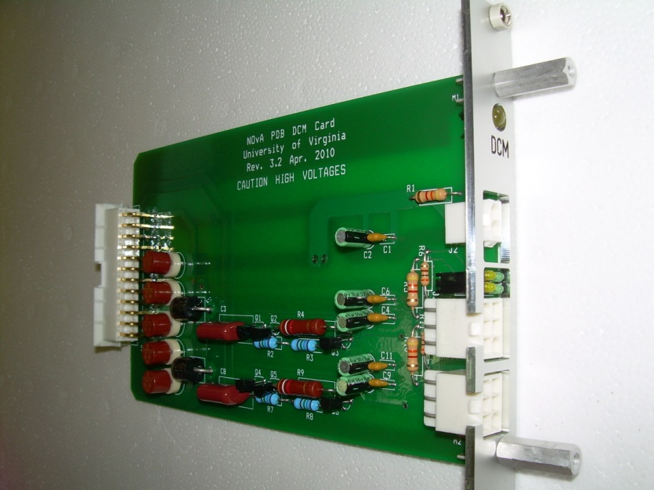
DCM Card
Faceplate
Standoff Screw
Retainer
Figure 9
4. Attaching the faceplates. Take a faceplate and stick a retainer (P#: 21100-464, Schroff) in the topmost and bottommost holes of it. Place a captive screw (P#: 21101-101, Schroff) in the retainers and then align the faceplate on the front its respective card. Attach the faceplate to the card using two standoff screws (P#: 8403, Keystone), one in each hole adjacent to the one for the retainers/captive screws.

5. Repeat step four until all 16 FEB cards, the Indicator card, and the DCM card have faceplates. Slide the cards into the card guide such that the Indicator card is closest to the switch panel, the DCM card is beside that, and then the 16 FEB cards stretch until the side panel.

6. Attach one stress relief bar to the box using #8 screws (P#: 90272A192, McMaster-Carr) through the last holes at the top of the side panels. Do the same to attach a second strain relief bar to the bottom holes at the rear of the side panels of the PDB. See Figure 5.

7. Stick a strip of kapton tape along the rear edges of the side panels to dull the sharp edges there. See Figure 6.

8. Place a PDB barcode label at the top center of the exterior of the back panel.
Dimensions of PDB:
Length: 16.5”
Width: 19”
Height: 5.25”

